Triggers in SQL Server

SQL Server triggers are special [stored procedures](https://www.sqlservertutorial.net/sql-server-stored-procedures/) that are executed automatically in response to the database object, database, and server events. SQL Server provides Two type of triggers

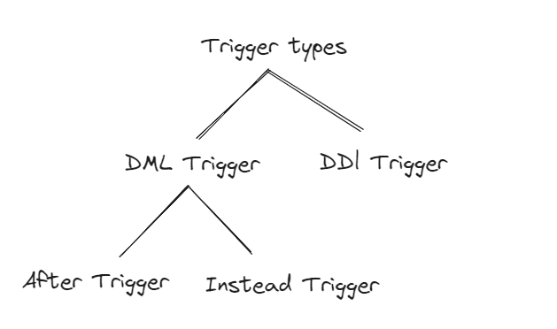

1. Data definition language (DDL) triggers which fire in response to [CREATE](https://www.sqlservertutorial.net/sql-server-basics/sql-server-create-table/), ALTER, and [DROP](https://www.sqlservertutorial.net/sql-server-basics/sql-server-drop-table/) statements. [DDL triggers](https://www.sqlservertutorial.net/sql-server-triggers/sql-server-ddl-trigger/) also fire in response to some system stored procedures that perform DDL-like operations.

One of Purpose 🡺 Make data base secure , trigger can prevent any one to make DDL in your data base ,any one cannot Create ,Alter and Drop .

Note 🡺 We can use trigger at many times and many purposes

Ex:

CREATE TRIGGER trigger_name

ON { DATABASE | ALL SERVER}

[WITH ddl_trigger_option]

For🡺crate ,alter ,drop table

As print🡺Don’t allow make this

Roolback ;